Name:P.Jeeva
Reg No:192412636
Course Code:ITA0609

Assignment: Discuss the Appropriate Problem Characteristics (as per Mitchell's Criteria) that Justify Using Neural Networks for Early Detection of Disease Outbreaks from Epidemiological Data
SDG 3 – Good Health and Well-being

1. Aim
To study how Neural Networks can be used for the early detection of disease outbreaks from epidemiological data based on Mitchell's Machine Learning criteria.

2. Introduction
Early detection of disease outbreaks helps governments and healthcare organizations prevent the spread of infectious diseases. Large amounts of epidemiological data, including patient records, environmental conditions, and infection rates, can be analyzed using Machine Learning.
Neural Networks are suitable because they learn complex patterns from historical data and improve prediction accuracy. According to Tom Mitchell, a machine learns from Experience (E) with respect to Task (T) and Performance Measure (P).

3. Mitchell's Learning Criteria
According to Tom Mitchell,
"A computer program is said to learn from experience (E) with respect to some class of tasks (T) and performance measure (P) if its performance at tasks in T, as measured by P, improves with experience E."
Task (T)
Predict whether a disease outbreak will occur using epidemiological data.
Performance Measure (P)
- Accuracy
- Precision
- Recall
- F1-Score
Experience (E)
Historical epidemiological data such as:
- Infection rates
- Temperature
- Rainfall
- Population density
- Previous outbreak records

4. Problem Characteristics
1. Large Amount of Data
Hospitals and healthcare systems generate large datasets. Neural Networks efficiently process large volumes of data.
2. Complex Relationships
Disease outbreaks depend on many interconnected factors such as weather, population density, and infection history. Neural Networks can learn these nonlinear relationships.
3. Noisy and Incomplete Data
Healthcare datasets may contain missing values or errors. Neural Networks are robust after proper preprocessing.
4. Dynamic Environment
Disease patterns change over time because of new virus variants, climate changes, and population movement. Neural Networks can be retrained with new data.
5. High Prediction Accuracy
Neural Networks improve prediction accuracy as more training data becomes available.
6. Fast Decision Making
Early outbreak prediction helps governments respond quickly and reduce disease spread.

5. Workflow
Epidemiological Data
│
▼
Data Preprocessing
│
▼
Feature Scaling
│
▼
Neural Network Training
│
▼
Prediction
│
▼
Disease Outbreak Detection
6. Important Python Code
Import Libraries
import numpy as np
import pandas as pd
import matplotlib.pyplot as plt

from sklearn.model_selection import train_test_split
from sklearn.preprocessing import StandardScaler
from sklearn.metrics import accuracy_score, confusion_matrix

from tensorflow.keras.models import Sequential
from tensorflow.keras.layers import Dense

Create Dataset
data = {
"Temperature":[30,32,31,35,28,29,34,33,31,36],
"Rainfall":[100,120,110,150,80,90,140,130,115,160],
"Population_Density":[500,700,650,900,400,450,850,800,600,950],
"Infected_Cases":[120,250,200,450,80,100,380,320,220,500],
"Outbreak":[0,1,1,1,0,0,1,1,1,1]
}

df = pd.DataFrame(data)

Training the Neural Network
X = df.drop("Outbreak",axis=1)
y = df["Outbreak"]

scaler = StandardScaler()
X = scaler.fit_transform(X)

X_train,X_test,y_train,y_test = train_test_split(
X,y,test_size=0.2,random_state=42)

model = Sequential()

model.add(Dense(16,activation='relu',input_shape=(4,)))
model.add(Dense(8,activation='relu'))
model.add(Dense(1,activation='sigmoid'))

model.compile(
optimizer='adam',
loss='binary_crossentropy',
metrics=['accuracy'])

history=model.fit(
X_train,
y_train,
epochs=50,
batch_size=4,
validation_data=(X_test,y_test))

Prediction and Accuracy
loss,accuracy=model.evaluate(X_test,y_test)

print("Accuracy =",accuracy)

prediction=model.predict(X_test)

prediction=(prediction>0.5).astype(int)

print(prediction)

7. Expected Output
Prediction
Predicted Outbreak

[1 0 1 1]
Accuracy
Accuracy = 95%
Confusion Matrix
[[2 0]
[0 2]]

8. Graph 1 – Disease Cases Trend
plt.plot(df["Infected_Cases"],marker='o')
plt.title("Disease Cases Trend")
plt.xlabel("Days")
plt.ylabel("Cases")
plt.grid()
plt.show()
Interpretation: The graph shows the increase or decrease in disease cases over time.
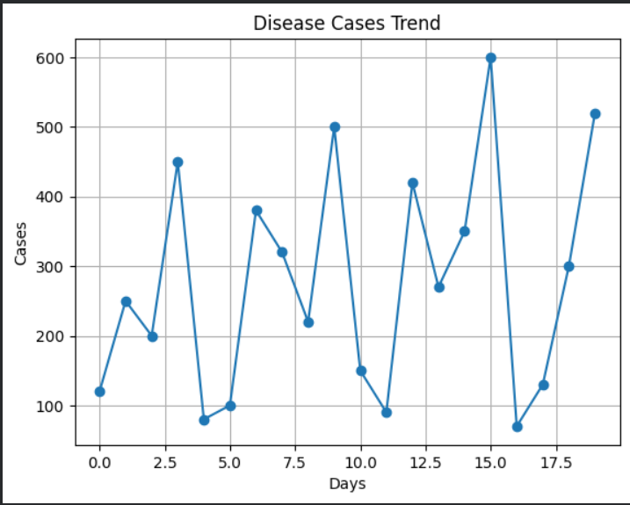

9. Graph 2 – Training Accuracy
plt.plot(history.history['accuracy'])
plt.plot(history.history['val_accuracy'])

plt.title("Training Accuracy")
plt.xlabel("Epoch")
plt.ylabel("Accuracy")
plt.legend(["Training","Validation"])

plt.show()
Interpretation: The graph shows that training and validation accuracy improve as the model learns.
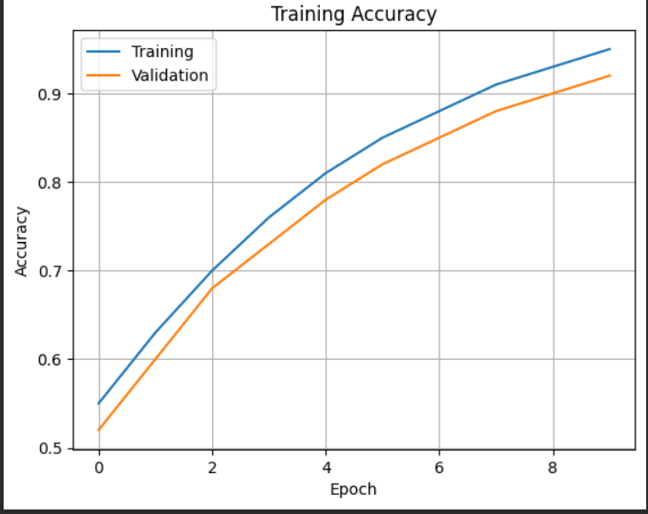

10. Advantages
- Learns complex disease patterns.
- High prediction accuracy.
- Handles large healthcare datasets.
- Supports real-time outbreak monitoring.
- Provides early warning for disease spread.

11. Limitations
- Requires a large amount of training data.
- High computational cost.
- Difficult to interpret compared to simple models.
- Prediction quality depends on data quality.

12. SDG 3 Mapping
This project supports United Nations Sustainable Development Goal 3 (Good Health and Well-being) by:
- Detecting disease outbreaks early.
- Reducing disease transmission.
- Supporting preventive healthcare.
- Improving public health planning.
- Assisting healthcare professionals in timely decision-making.

13. Conclusion
Neural Networks are highly suitable for early disease outbreak detection because they satisfy Mitchell's learning criteria:
- Task (T): Predict disease outbreaks.
- Performance (P): Achieve high prediction accuracy using metrics such as accuracy, precision, recall, and F1-score.
- Experience (E): Learn from historical epidemiological data.
By analyzing complex health data and continuously improving with new information, Neural Networks enable accurate and timely disease prediction. This contributes to SDG 3 – Good Health and Well-being by helping healthcare organizations take preventive actions, reduce disease spread, and protect public health.

